Paul Polsinelli

IFT 410 - 22485

4/4/2021

# Lab 10: BD Storage with Databricks

### **Part II: Creating a Database using Databricks**

Create database Movie;

Create table Movie.UserTable (UserID INT, UserName STRING, Password STRING, Start_Date DATE);

Create table Movie.Movie_Table (MovieID INT, Title String, Genre STRING, Year DOUBLE, CastCrew STRING, Director STRING);

Create table Movie.Ratings_Table (UserID INT, MovieID INT, Rating DOUBLE, TimeStamp TIMESTAMP);

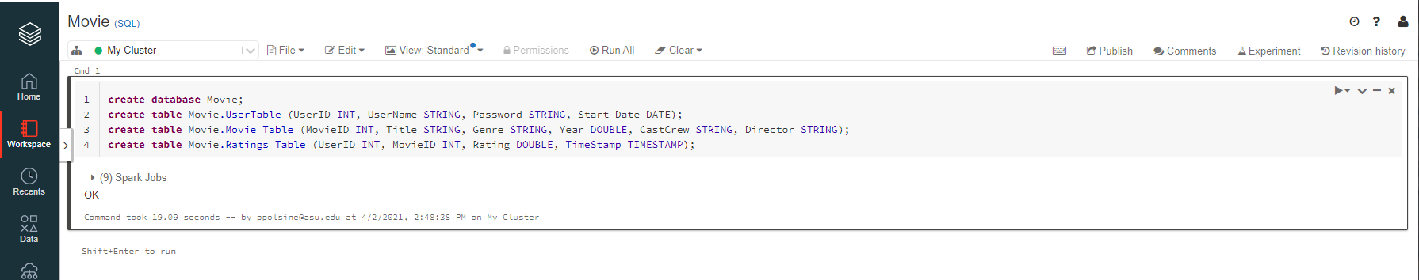

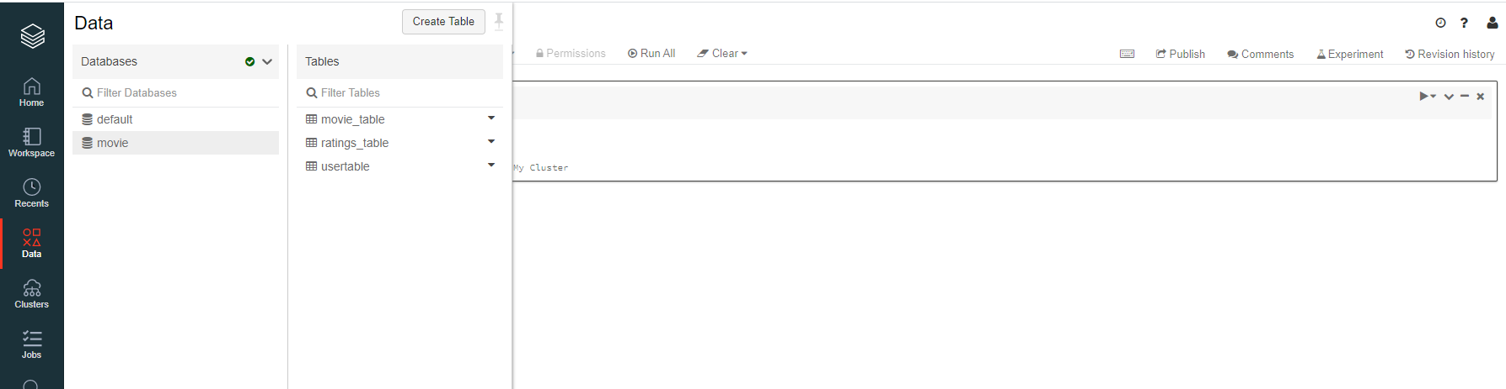

SET time_zone='+00:00';

insert into Movie.Ratings_table values (1,1,1,'2021-01-01 01:00:01');

insert into Movie.Ratings_table values (2,1,2,'2020-01-01 02:00:01');

insert into Movie.Ratings_table values (3,1,3,'2019-01-01 03:00:01');

insert into Movie.Ratings_table values (4,2,4,'2018-01-01 04:00:01');

insert into Movie.Ratings_table values (5,2,5,'2017-01-01 05:00:01');

insert into Movie.Ratings_table values (6,2,1,'2016-01-01 06:00:01');

insert into Movie.Ratings_table values (7,3,2,'2015-01-01 07:00:01');

insert into Movie.Ratings_table values (8,3,3,'2014-01-01 08:00:01');

insert into Movie.Ratings_table values (9,3,4,'2013-01-01 09:00:01');

insert into Movie.Ratings_table values (10,3,5,'2012-01-01 09:00:01');

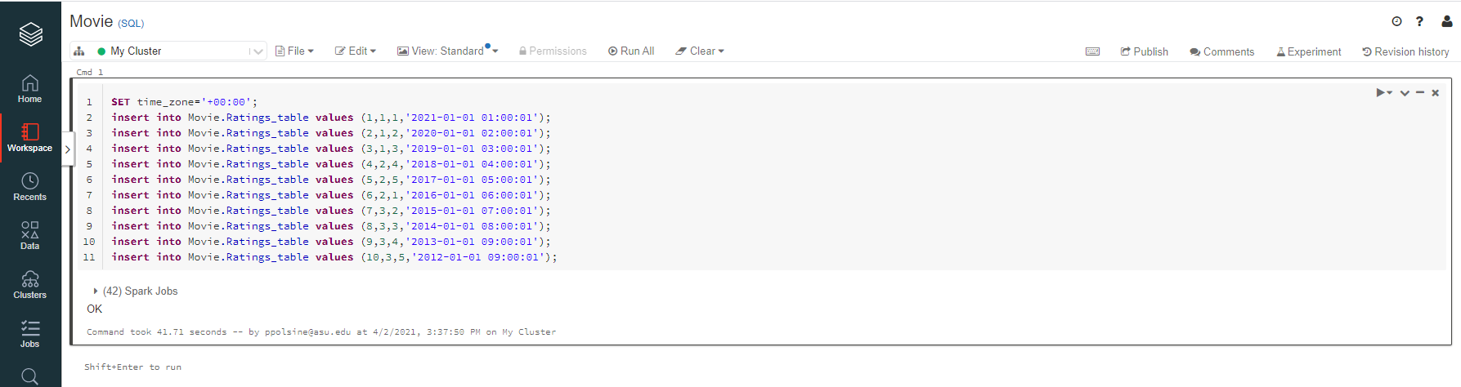

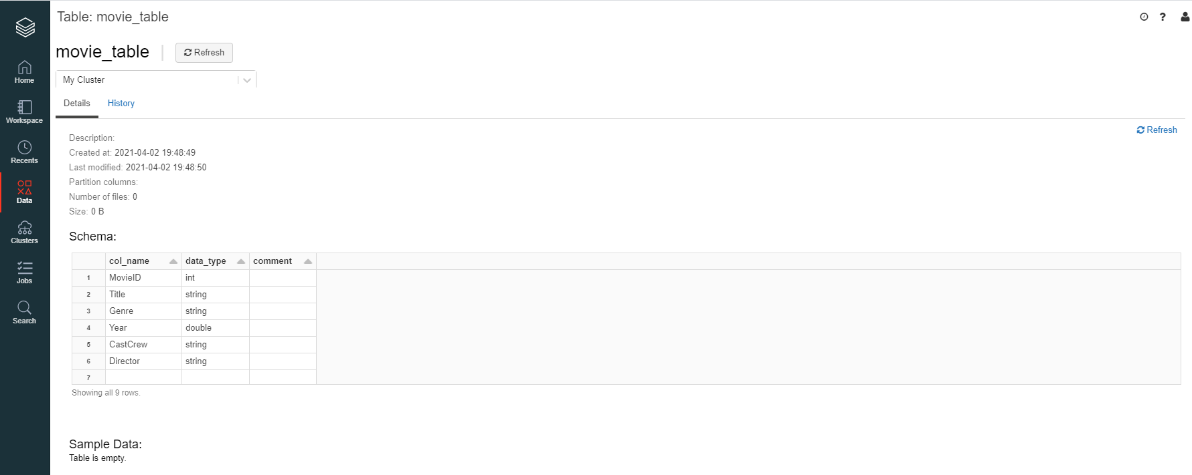

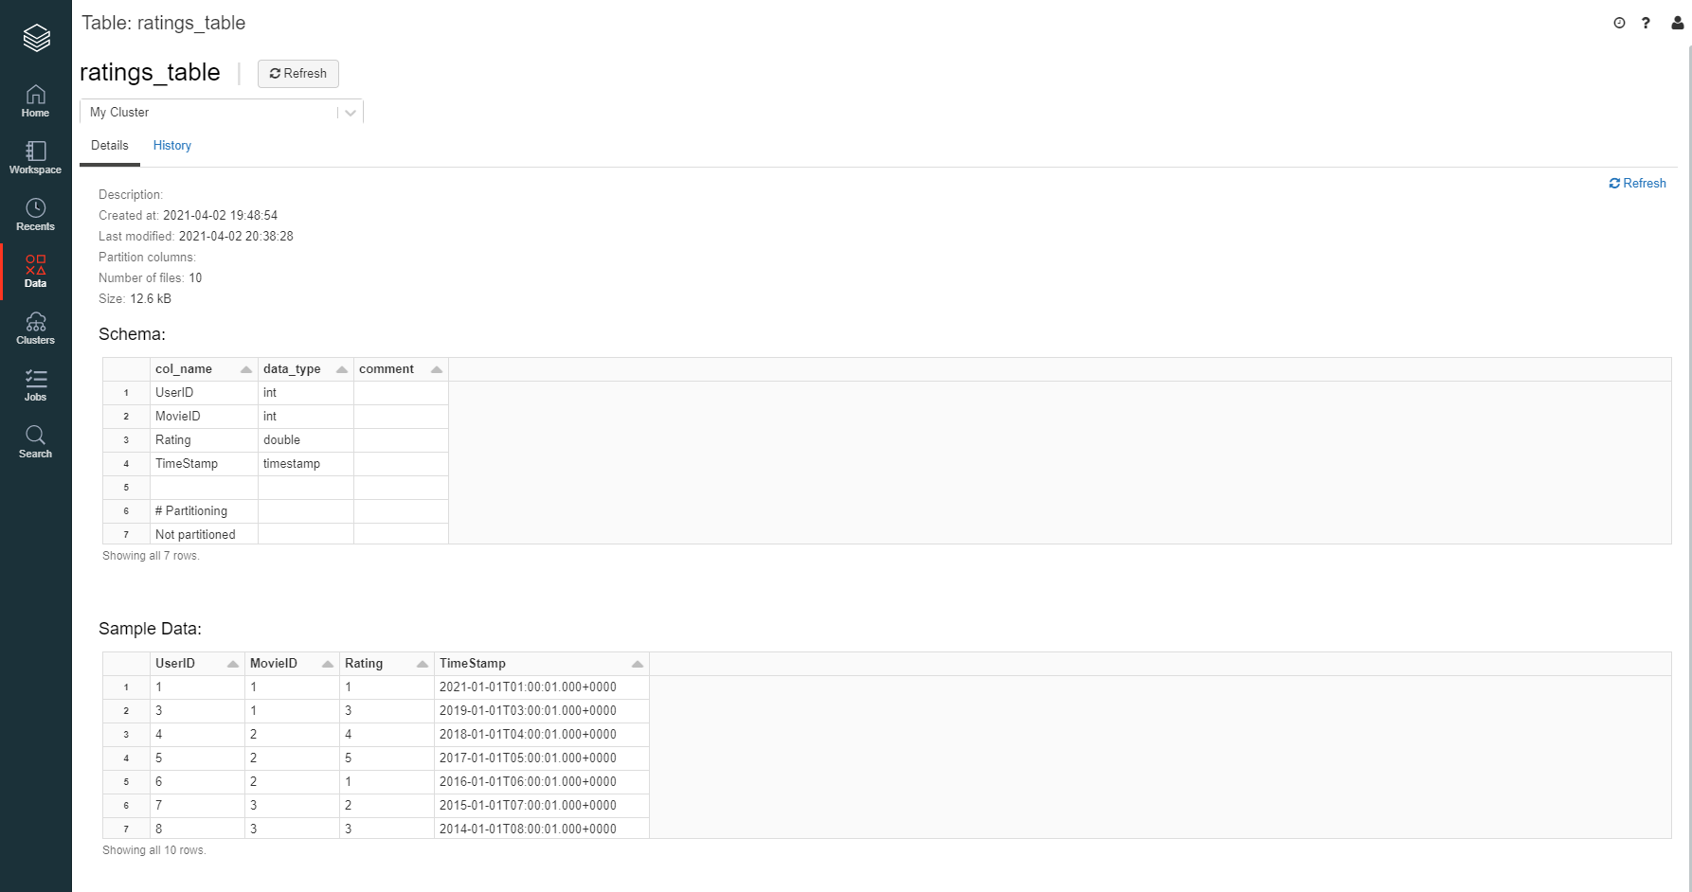

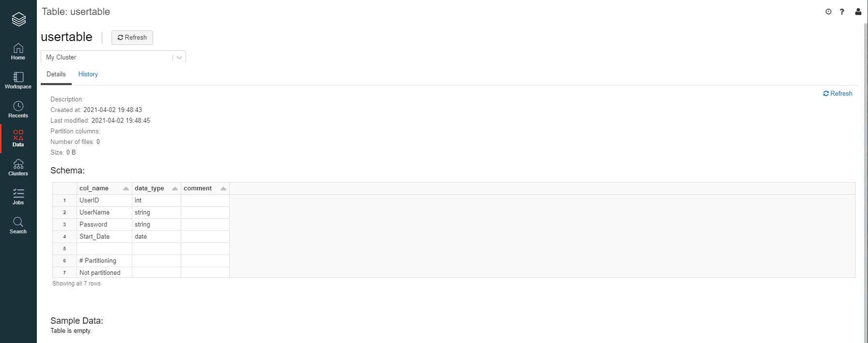

SELECT MovieID, AVG(Rating)

FROM movie.ratings_table

GROUP BY MovieID;

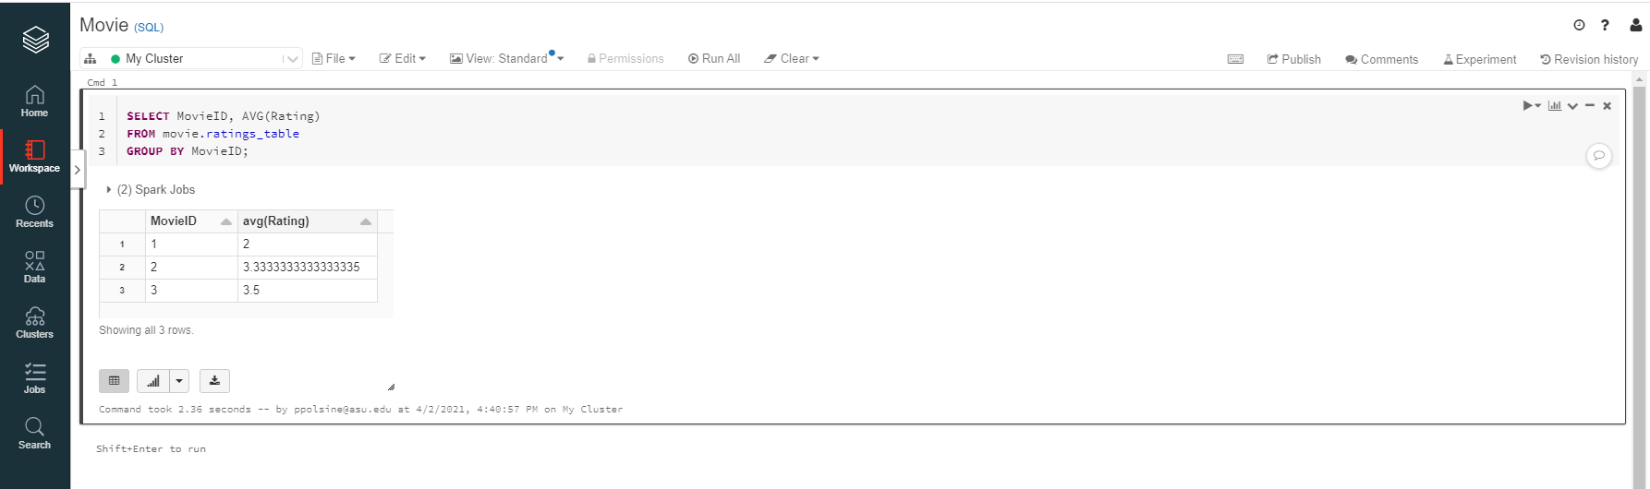

### **Part III: Querying Data Stored in a CSV File**

### This query shows all the movieID’s that userID 4 gave a rating of 3

val sqlDF = spark.sql("SELECT _c1 FROM csv.`/FileStore/tables/ratings.csv` where _c0=4 AND _c2=3")

sqlDF.show()

